**Software Requirements**

**Specification**

**for**

**LSC Learning Management System**

**Version 1.0 approved**

**Prepared by:  
Gardon, Jana Marie G.  
Heramia, Johanna Marisse C.  
Tadeo, Jose Lorenzo G.**

**Asia Pacific College 10/21/16**

**Copyright © 1999 by Karl E. Wiegers. Permission is granted to use, modify, and distribute this document.**

**Software Requirements Specification for LSC Learning Management System Page ii**

# Table of Contents

Table of Contents ii

Revision History ii

1. Introduction 1

1.1 Purpose 1

1.2 Document Conventions 1

1.3 Intended Audience and Reading Suggestions 1

1.4 Product Scope 1

1.5 References 1

2. Overall Description 2

2.1 Product Perspective 2

2.2 Product Functions 2

2.3 User Classes and Characteristics 2

2.4 Operating Environment 2

2.5 Design and Implementation Constraints 2

2.6 User Documentation 2

2.7 Assumptions and Dependencies 3

3. External Interface Requirements 3

3.1 User Interfaces 3

3.2 Hardware Interfaces 3

3.3 Software Interfaces 3

3.4 Communications Interfaces 3

4. System Features 4

4.1 System Feature 1 4

4.2 System Feature 2 (and so on) 4

5. Other Nonfunctional Requirements 4

5.1 Performance Requirements 4

5.2 Safety Requirements 5

5.3 Security Requirements 5

5.4 Software Quality Attributes 5

5.5 Business Rules 5

6. Other Requirements 5

Appendix A: Glossary 5

Appendix B: Analysis Models 5

Appendix C: To Be Determined List 6

# Revision History

|  |  |  |  |
| --- | --- | --- | --- |
| **Name** | **Date** | **Reason For Changes** | **Version** |
|  |  |  |  |
|  |  |  |  |

# Introduction

## Purpose

The purpose of software requirement specification is to provide a full description of the Learning Management System functionalities, the stakeholders, and the requirements to implement the Learning Management System (LMS), so that the Loyola Student Center (LSC), our client, can verify all the necessary content that is included and the team can have the complete understanding in the development of the project.

The following are the objectives of the SRS:

* To serve as a basis for improvement of the finished system
* To provide a realistic basis for estimating costs and schedules
* To provide a basis for developing the software design
* To establish the basis for agreement between the client and the system developers

<Identify the product whose software requirements are specified in this document, including the revision or release number. Describe the scope of the product that is covered by this SRS, particularly if this SRS describes only part of the system or a single subsystem.>

## Document Conventions

This document is set in Microsoft Word 2016, with a font “Arial” and font size of 11. Each part of the document is written as header 1 and under each part are in header 2; both are in bold property.

**Acronym and Abbreviations:**

1. LMS: Learning Management System
2. SRS: Software Requirement Specification
3. LSC: Loyola Student Center

<Describe any standards or typographical conventions that were followed when writing this SRS, such as fonts or highlighting that have special significance. For example, state whether priorities for higher-level requirements are assumed to be inherited by detailed requirements, or whether every requirement statement is to have its own priority.>

## Intended Audience and Reading Suggestions

The intended readers of the SRS document are the following:

* Developers - Developers are those who manage the entire document and system. They may use this document to implement the functionalities and to ensure to be in the right track while doing the LSC LMS. When there are changes that are needed, they can look through this document.
* Project Managers - The project manager may use this document to manage the entire LSC LMS.
* Testers – The testers may use this document to have knowledge on how and what the LMS is capable of doing. They will test the developed system with the given certain cases and estimates the performance of the system.
* Writers of the documents – The document writers may use this document to know the proper flow in creating a document and they are the one that who are going to prepare the user manuals and other necessary documents of the system.
* Users – Users are those who will be needing this system. The users would use this document to have knowledge in the different functions and interfaces of the LSC LMS. They could also use this document to know the difference between LSC-LMS to other existing LMS. This can be used for easy access and familiarization to the system since this system will be used mostly by them. They could also be able to examine the software consequently and could check in this document the suitable requirements and whether developers had implemented it all.   
    
  The remaining information in this document are describing the functional requirements of the system.

<Describe the different types of reader that the document is intended for, such as developers, project managers, marketing staff, users, testers, and documentation writers. Describe what the rest of this SRS contains and how it is organized. Suggest a sequence for reading the document, beginning with the overview sections and proceeding through the sections that are most pertinent to each reader type.>

## Scope

The LSC LMS is a software application that aims to improve the current system of LSC in giving tasks, announcing important announcements and tracking of students. It will not a=only benefit the management of the LSC but also the students who enrolled in their classes.  
 For the students, they will be able to take tasks online, to track their performance based on the results of their tasks, to easily know if there are tasks to do through the calendar and to also track their attendance. For the tutor, they will be able to create courses in classes and add student to that course, to add tasks (in task, the tutor can give on how many attempts the student can have and can also put time limits) and to track the attendance of students.   
 So, using this LSC-LMS, it can provide better service and chance for the students of Loyola Student Center in passing their targeted school or college and to pass to their exams. For the goal of LSC-LMS, refer to the “Project Vision and Scope Document”.

<Provide a short description of the software being specified and its purpose, including relevant benefits, objectives, and goals. Relate the software to corporate goals or business strategies. If a separate vision and scope document is available, refer to it rather than duplicating its contents here.>

## References

The following are the references for the documents of LSC-LMS:

* Minimum Requirements for Web Based Applications. (2016, February 26). Retrieved October 22, 2016, from https://support.skyward.com/DeptDocs/Corporate/IT Services/Public Website/Technical Information/Workstation Requirements/Web Based Workstation Requirements.pdf
* Project – LSC Group 2 – 101. Retrieved from <http://projects2.apc.edu.ph/wiki/index.php/Project_-_LSC_Group_2_-101>
* BS Education Free CSS Template. (2015, December 11). Retrieved from <http://www.free-css.com/free-css-templates/page193/bs-education>

<List any other documents or Web addresses to which this SRS refers. These may include user interface style guides, contracts, standards, system requirements specifications, use case documents, or a vision and scope document. Provide enough information so that the reader could access a copy of each reference, including title, author, version number, date, and source or location.>

# Overall Description

## Product Perspective

LSC Learning Management System aims to improve the existing system of the LSC that enable the student to have access on their class curriculum like exercises and assignments online and enables the admin to save students class information which makes the data more organized. This software can help integrate the system then later be released and accessed. It is used to replace their paper-based existing system and some of functionalities of the LSC-LMS may be similar to other existing LMS, however this system is made only for the LSC student, instructor and admin that has specific requirements requested by the client

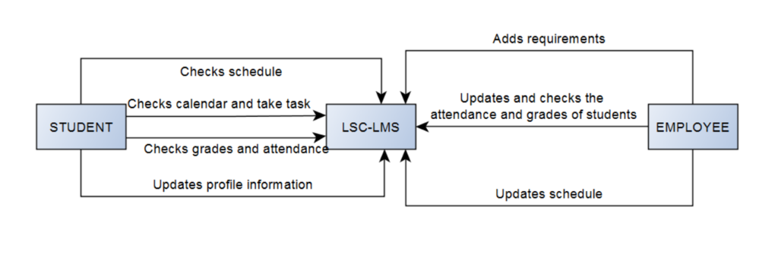

<Describe the context and origin of the product being specified in this SRS. For example, state whether this product is a follow-on member of a product family, a replacement for certain existing systems, or a new, self-contained product. If the SRS defines a component of a larger system, relate the requirements of the larger system to the functionality of this software and identify interfaces between the two. A simple diagram that shows the major components of the overall system, subsystem interconnections, and external interfaces can be helpful.>

## Product Functions

The Loyola Student Center Learning Management System is provided for the LSC Management and for the students. Before the student or employee could do the following, he or she must have an account first. The following are the functions of LSC LMS:

* Employee:
  + Can create a course for review class for the students
  + Can record the student’s attendance during the class
  + Can create and assign task such as assignments, quizzes and exercise
  + Can give announcements through the calendar
  + Can update the student’s grades
* Student:
  + Can access the review class
  + Can view their attendance
  + Can take tasks
  + Can see the announcements through calendar
  + Can keep track with their grades

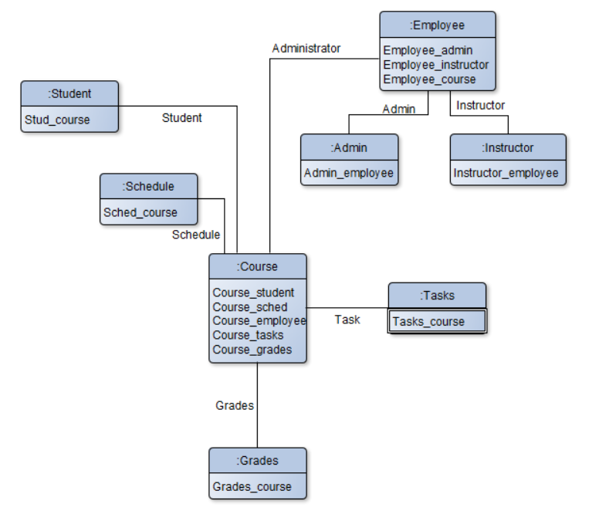

<Summarize the major functions the product must perform or must let the user perform. Details will be provided in Section 3, so only a high level summary (such as a bullet list) is needed here. Organize the functions to make them understandable to any reader of the SRS. A picture of the major groups of related requirements and how they relate, such as a top level data flow diagram or object class diagram, is often effective.>

## User Classes and Characteristics

There are three kinds of users that are expected to use the LSC-Learning Management System. Each kind of user has their own roles and should perform different operations within the system.

* Administrative staff (or System administrator), users with the LSC LMS administrator knowledge
* Tutors or Lecturers, users with LSC LMS usage knowledge
* Students, users with LSC LMS usage knowledge

The administrator must be familiar with the web applications and shall configure the environment for the rest of the users who does have the LSC LMS database knowledge or information so they can use the LSC LMS without problems

Tutors or lecturers should have at least basic knowledge in managing computer devices. The professors or lecturers will be the one who will create courses and will manage the students’ records in class such as checking of the attendance and who will give assignments, exercises or quizzes to classes.

Students should have at least basic knowledge on what the LMS can do. The students can use the LMS to view their records and take tasks such as assignments, quiz, or exercise.

<Identify the various user classes that you anticipate will use this product. User classes may be differentiated based on frequency of use, subset of product functions used, technical expertise, security or privilege levels, educational level, or experience. Describe the pertinent characteristics of each user class. Certain requirements may pertain only to certain user classes. Distinguish the most important user classes for this product from those who are less important to satisfy.>

## Operating Environment

OE_1: The LSC LMS shall operate with any web browser and It is recommended that it is in the latest version.  
OE_2: The LSC LMS shall operate on Windows, iOS, Linux and Android operating system  
OE_3: The LSC LMS can be accessed by any LSC students or personnel.

OE_4: The LSC LMS backend can only be accessed inside the LSC premises only.  
OE_5: Minimum hardware requirements: Dual Core 1.6GHz of faster. RAM: 1 gigabyte (GB) (32-bit) or 2 GB (64-bit).

<Describe the environment in which the software will operate, including the hardware platform, operating system and versions, and any other software components or applications with which it must peacefully coexist.>

## Design and Implementation Constraints

The LSC students and admin can use this system because the information must be kept within LSC-LMS users only. While the students are taking the exam, right click is invalid to avoid printing the questions.

DaIC_1: The LSC Learning Management System design’s and functionalities shall adapt or modify the process of the current system of LSC.  
DaIC_2: The LSC Learning Management System must follow the given requirements of the client.  
DaIC_3: The LSC Learning Management System must perform validation checks in user’s input  
DaIC_4: The materials that will be using online should not printable or not right clickable for the students to be able to not to share it online or with anyone.  
DaIC_5: The system uses PhpmyAdmin MySQL for the database/  
DaIC_6: The system uses Yii2 (advance template) and Admin LTE (theme in backend) to build the system.  
DaIC_7: PHP, CSS and JavaScript are being combined in creating the system interfaces

<Describe any items or issues that will limit the options available to the developers. These might include: corporate or regulatory policies; hardware limitations (timing requirements, memory requirements); interfaces to other applications; specific technologies, tools, and databases to be used; parallel operations; language requirements; communications protocols; security considerations; design conventions or programming standards (for example, if the customer’s organization will be responsible for maintaining the delivered software).>

## User Documentation

Together with the LSC LMS, for the user of it to be able to understand on how does it work and what are the usage of the system, user manuals will be written and provided under the client’s perspective and understanding. The readers of manuals are being assume that they are nontechnical readers thus, every terminology are easy to understand. The user manual includes step-by-step procedures.

<List the user documentation components (such as user manuals, on-line help, and tutorials) that will be delivered along with the software. Identify any known user documentation delivery formats or standards.>

## Assumptions and Dependencies

Assumptions are made such as:

* Once the student is enrolled he or she can already have a LSC account.
* They can take exercises and assignments, and can view the results and grades.
* It lets the student to monitor their attendance as the instructor will check the attendance using LMS.
* The student can be notified when there are upcoming events and tasks.
* Since it is an account, there is a profile page that contains personal information of the student.
* The instructor can add tasks on each of the student’s account.
* The instructor can add events on the calendar.

Dependencies:

* A student must enroll first to have a LSC-LMS account.
* It must be connected to the internet to access it.
* A browser is needed to access and view the system.

<List any assumed factors (as opposed to known facts) that could affect the requirements stated in the SRS. These could include third-party or commercial components that you plan to use, issues around the development or operating environment, or constraints. The project could be affected if these assumptions are incorrect, are not shared, or change. Also identify any dependencies the project has on external factors, such as software components that you intend to reuse from another project, unless they are already documented elsewhere (for example, in the vision and scope document or the project plan).>

# External Interface Requirements

## User Interfaces

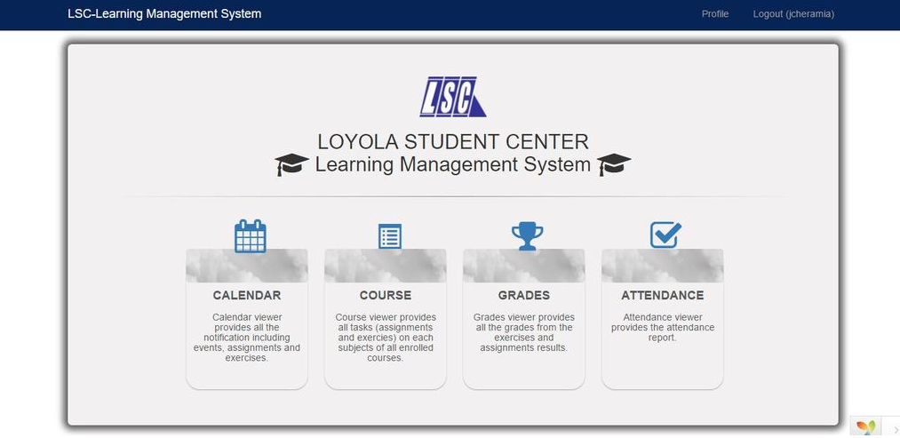

This is the sample main page for the student in frontend. There are four sections: calendar, course, grades and attendance. In calendar, the student can check their schedule of their classes and also if there are tasks that they need to do. The calendar will as the reminder for the students. Next is the course. In this section, the student can see their courses that their tutor created. Then for the grade section, the student can see their grades of their different tasks. Lastly the attendance. The student can see their attendance in a specific course. This section will let them know if how many absences they had in the past.

<Describe the logical characteristics of each interface between the software product and the users. This may include sample screen images, any GUI standards or product family style guides that are to be followed, screen layout constraints, standard buttons and functions (e.g., help) that will appear on every screen, keyboard shortcuts, error message display standards, and so on. Define the software components for which a user interface is needed. Details of the user interface design should be documented in a separate user interface specification.>

## Hardware Interfaces

The needed hardware interfaces to use the LSC-LMS are the following:

* Computer w/ a 64 bit

<Describe the logical and physical characteristics of each interface between the software product and the hardware components of the system. This may include the supported device types, the nature of the data and control interactions between the software and the hardware, and communication protocols to be used.>

## Software Interfaces

The needed software interfaces to use the LSC-LMS are the following:

* Windows based operating system (preferably)
* Web browser

<Describe the connections between this product and other specific software components (name and version), including databases, operating systems, tools, libraries, and integrated commercial components. Identify the data items or messages coming into the system and going out and describe the purpose of each. Describe the services needed and the nature of communications. Refer to documents that describe detailed application programming interface protocols. Identify data that will be shared across software components. If the data sharing mechanism must be implemented in a specific way (for example, use of a global data area in a multitasking operating system), specify this as an implementation constraint.>

## Communications Interfaces

<Describe the requirements associated with any communications functions required by this product, including e-mail, web browser, network server communications protocols, electronic forms, and so on. Define any pertinent message formatting. Identify any communication standards that will be used, such as FTP or HTTP. Specify any communication security or encryption issues, data transfer rates, and synchronization mechanisms.>

# System Features

<This template illustrates organizing the functional requirements for the product by system features, the major services provided by the product. You may prefer to organize this section by use case, mode of operation, user class, object class, functional hierarchy, or combinations of these, whatever makes the most logical sense for your product.>

## Creating course

**4.1.1 Description and Priority**

The admin/lecturer provide the students a course to access the learning materials of a review class. The priority of creating a course is High.

**4.1.2 Stimulus/Response Sequences**

* **Stimulus**: The admin/lecturer creates new course
* **Response**: The added course will be inserted in the database and the page will display

**4.1.3 Functional Requirements**

**REQ-1:** The admin/lecturer should have an account

## 4.2 Adding tasks

## 4.2.1 Description and Priority

The admin/lecturer adds tasks such as assignments and exercises for the student. The priority of adding a task is Medium.

**4.2.2 Stimulus/Response Sequences**

* **Stimulus**: The admin/lecturer access the course link
* **Response**: The course page is displayed
* **Stimulus:** The admin/lecturer adds a task
* **Response**: The added course will be inserted in the database and the task page will display

**4.2.3 Functional Requirements**

**REQ-1:** The admin/lecturer should have an account

**REQ-2:** There should be an existing course

**4.3 Making announcement in calendar**

**4.3.1 Description and Priority**

The admin/lecturer can make announcement the calendar. The priority of making an announcement in calendar is Low.

**4.3.2 Stimulus/Response Sequences**

* **Stimulus:** The admin/lecturer access calendar link
* **Response:** The calendar page will display
* **Stimulus:** The admin/lecturer will select a date and add an announcement
* **Response:** The announcement will be displayed inside the selected date

**4.3.3 Functional Requirements**

**REQ-1:** The admin/lecturer should have an account

**4.4 Listing attendance**

**4.4.1 Description and Priority**

The admin/lecturer can list the attendances of the students whether he or she is present during the class. The priority of listing the attendance of the student is High.

**4.4.2 Stimulus/Responses Sequences**

* **Stimulus: The admin/lecturer access the attendance link**
* **Response: The attendance page will display**
* **Stimulus: The admin/lecturer select’s a student and updates his or her status during the class**
* **Response: The updated status of the student will be saved in a database to keep track of the student’s attendance**

**4.4.3 Functional Requirements**

**REQ-1: The admin/lecturer should have an account**

**REQ-2: The admin/lecturer should be enrolled in the review class**

**REQ-3: The student should have an account**

**REQ-4: The student should be enrolled in the review class of the lecturer**

<Don’t really say “System Feature 1.” State the feature name in just a few words.> 4.1.1 Description and Priority

<Provide a short description of the feature and indicate whether it is of High, Medium, or Low priority. You could also include specific priority component ratings, such as benefit, penalty, cost, and risk (each rated on a relative scale from a low of 1 to a high of 9).>

4.1.2 Stimulus/Response Sequences

<List the sequences of user actions and system responses that stimulate the behavior defined for this feature. These will correspond to the dialog elements associated with use cases.>

4.1.3 Functional Requirements

<Itemize the detailed functional requirements associated with this feature. These are the software capabilities that must be present in order for the user to carry out the services provided by the feature, or to execute the use case. Include how the product should respond to anticipated error conditions or invalid inputs.

Requirements should be concise, complete, unambiguous, verifiable, and necessary. Use “TBD” as a placeholder to indicate when necessary information is not yet available.>

<Each requirement should be uniquely identified with a sequence number or a meaningful tag of some kind.>

REQ-1:

REQ-2:

# Other Nonfunctional Requirements

## Performance Requirements

* The response of the system depends on whether the internet connection is slow or fast.
* The system shall display a confirmation message to users right after the user submits his or her answers in the exercises and assignments.
* The calendar will notify when there is an upcoming event or task to do.
* The system should generate policy with an accuracy of 99%
* The time and date when the user pass the task or the instructor adds task and event, and delete task, depends on the time and date on the user’s device.

<If there are performance requirements for the product under various circumstances, state them here and explain their rationale, to help the developers understand the intent and make suitable design choices. Specify the timing relationships for real time systems. Make such requirements as specific as possible. You may need to state performance requirements for individual functional requirements or features.>

## Safety Requirements

The LSC LMS must only be authorized by LSC students, admin and instructors only. All the information is restricted and must not access by non-LSC students and employees. All the exercises and assignments must be secured well. During taking the task, the user can’t right click the page to avoid printing the questions. There is a consistency since the system is connected to only one server.

<Specify those requirements that are concerned with possible loss, damage, or harm that could result from the use of the product. Define any safeguards or actions that must be taken, as well as actions that must be prevented. Refer to any external policies or regulations that state safety issues that affect the product’s design or use. Define any safety certifications that must be satisfied.>

## Security Requirements

The security requirement of the LSC are: only the approved students of the LSC can access the LSC-LMS and the task that will be given by LSC such as assignments and exercises should not be printed or saved in any devices. The team’s solution for both security requirements are, the students email and password will be created when the administration of the LSC approved of his or her account. Regarding with the task security, the team came up with the solution of “not right clickable” making the task unable to save and print.

<Specify any requirements regarding security or privacy issues surrounding use of the product or protection of the data used or created by the product. Define any user identity authentication requirements. Refer to any external policies or regulations containing security issues that affect the product. Define any security or privacy certifications that must be satisfied.>

## Software Quality Attributes

The Optimized Learning Management System shall be available to users all the time as long as there is an internet connection.

<Specify any additional quality characteristics for the product that will be important to either the customers or the developers. Some to consider are: adaptability, availability, correctness, flexibility, interoperability, maintainability, portability, reliability, reusability, robustness, testability, and usability. Write these to be specific, quantitative, and verifiable when possible. At the least, clarify the relative preferences for various attributes, such as ease of use over ease of learning.>

## Business Rules

LSC Learning Management System will be used by the LSC students, instructor and admin. The student will automatically have a LSC-LMS account once he/she is already enrolled. The admin is responsible on the update of the personal information of the student while the instructor add course, subjects, tasks, events and check attendance to each of the student’s account.

<List any operating principles about the product, such as which individuals or roles can perform which functions under specific circumstances. These are not functional requirements in themselves, but they may imply certain functional requirements to enforce the rules.>

# Other Requirements

<Define any other requirements not covered elsewhere in the SRS. This might include database requirements, internationalization requirements, legal requirements, reuse objectives for the project, and so on. Add any new sections that are pertinent to the project.>

# Appendix A: Glossary

<Define all the terms necessary to properly interpret the SRS, including acronyms and abbreviations. You may wish to build a separate glossary that spans multiple projects or the entire

organization, and just include terms specific to a single project in each SRS.>

# Appendix B: Analysis Models

The Entity Relationship Diagram (ERD) was analyzed upon the requirements of the LSC.

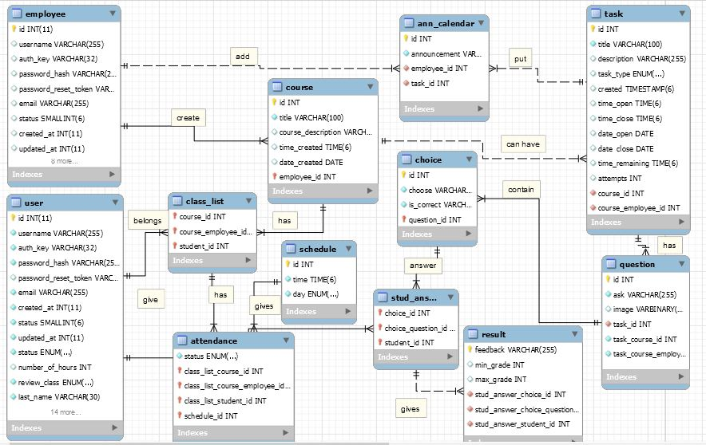

<Optionally, include any pertinent analysis models, such as data flow diagrams, class diagrams, state-transition diagrams, or entity-relationship diagrams.>

# Appendix C: To Be Determined List

<Collect a numbered list of the TBD (to be determined) references that remain in the SRS so they can be tracked to closure.>